**Briefing: Enhancing South Australia's Tourism through Innovative Smart Tourism App**

Objective:

The purpose of this briefing is to introduce our innovative proposal for addressing the challenges faced by **South Australia's tourism industry**, primarily focusing on **increasing visitor expenditure and promoting the state's diverse tourism offerings through gamification**. We believe that by creating a unique Smart Tourism App, we can attract more tourists, both international and interstate, and contribute to the growth of the state's economy.

Challenges:

* Increase visitor expenditure through Smart Tourism
* Highlight the diversity of South Australia’s tourism product through gamification

Improvement Opportunity

While Australia has experienced an increase in tourism, South Australia has not attracted its fair share of tourists. We aim to bridge this gap by providing incentives for tourists to spend more during their visits.

South Australia boasts a diverse range of tourism experiences, yet these offerings are not being effectively highlighted. Our proposal aims to showcase the richness of the state's tourism product through engaging gamification elements.

We have conducted an analysis using data from the South Australia Government's tourism statistics database, which can be accessed through this URL: <https://data.sa.gov.au/data/dataset/00824055-585f-488e-a7df-4ea9fd678496/resource/580047b5-132c-48f1-b96e-577ede59ec21/download/cusersjacksm01desktopsatc-tourism-visitor-statsitics.xlsx>. This analysis has revealed that South Australia lags behind in attracting tourists compared to other parts of Australia. There is also a significant disparity in the average number of nights spent by international visitors in South Australia when compared to the national average.

Proposed Solution:

Our proposal is to develop a cutting-edge Smart Tourism App that leverages innovative features to enhance visitor experiences and promote spending within South Australia's tourism sector.

**Cashback Incentives**: The core feature of our app is a cashback policy, where users are rewarded with cashback for every purchase made on tourism-related items. This approach is expected to encourage tourists and locals alike to explore more and spend more during their travels.

After some time of use, this app will create a rich database of tourist preferences in a deep level of granularity. GPS location, amount spent, time spent, and weather conditions to mention some of the fields that can be generated. ALL THIS INFORMATION CAN BE USED IN THE FUTURE FOR DECISION MAKING.

**Gamification Elements based on Culture, Heritage, and Nature**: To engage travelers of all ages, we will integrate interactive games into the app. These games will not only entertain users but also educate them about **South Australia's Culture, Heritage, and Nature**. Families traveling with children will find these games particularly engaging, creating a memorable and enriching experience.

Future versions of the apps will be available with new games proposed by our users.

**Route Mapping**: The app will include a map feature that identifies points of interest along a traveler's route. This will help users discover interesting places and activities to do, enriching their journey and encouraging them to explore more of the state, that means staying longer.

**Alignment with Government Goals:**

While the South Australia Government's efforts to improve tourism are commendable, we believe our app can complement their initiatives and contribute significantly to achieving their goals. By incorporating our app into their planning and tools, the government can tap into a new avenue of increasing visitor expenditure and highlighting the state's tourism diversity.

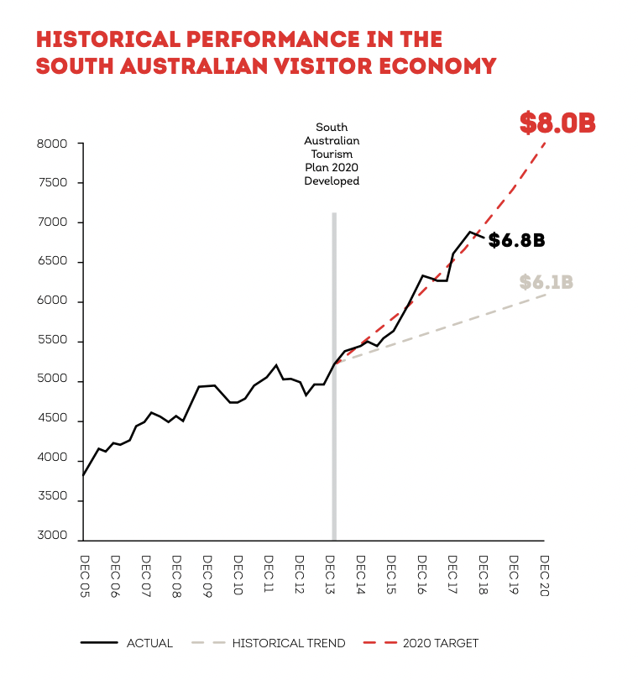

**APP Versions:**

Our first version will focus on family & kids. We will partner with Schools to encourage kids to play during their vacations and develop the education materials.

Future versions:  
v2.0 Explore more regions

v3.0 International backpackers

v4.0 Users can propose new games and features

v5.0 Augmented Reality

**Conclusion:**

Our proposal for the Smart Tourism App addresses the challenges faced by South Australia's tourism industry in an innovative and engaging manner. **By incentivizing spending through cashback rewards, incorporating educational games, and enhancing the travel experience through route mapping**. We are confident that we can help South Australia become a more attractive and enriching destination for tourists from around the world. We look forward to collaborating with the South Australia Government to make this vision a reality and contribute positively to the state's economy and tourism sector.